 | Digital Preservation Technical Paper: | 1

The TNA Preservation Metadata Scheme

Document Control

Author: | Adrian Brown, Services Manager
Document Reference: | DPTP-01
Issue: | 0a
Issue Date: | 12 November 2003

©THE NATIONAL ARCHIVES 2003
Contents

1 Introduction 4
2 Background 4
3 Information model 5
4 Metadata Elements 7
4.1 Accession 7
4.1.1 Metadata Map 7
4.1.2 Element Descriptions 8
4.2 Record 22
4.2.1 Metadata Map 22
4.2.2 Element Descriptions 23
4.3 Manifestation 31
4.3.1 Metadata Map 31
4.3.2 Element Descriptions 32
4.4 File 41
4.4.1 Metadata Map 41
4.4.2 Element Descriptions 42
4.5 Type-specific extensions 48
5 Bibliography 50

Introduction

This document is the first in a series of technical papers produced by the Digital Preservation Department of The National Archives, covering detailed technical issues related to the preservation and management of electronic records.

This technical paper describes the preservation metadata scheme developed by TNA for use within its Digital Archive system. Advice and guidance on the use of this scheme by bodies transferring records to TNA can be provided by Digital Preservation Department.

Background

The first version of the metadata scheme was developed in 2002, and implemented in April 2003, as part of the operational release of the TNA Digital Archive system. The following existing metadata schemes were consulted as part of this process:

 OCLC/RLG

 National Library of Australia

 National Library of New Zealand

 VERS

 CEDARS

- NEDLIB

- English Heritage Centre for Archaeology

- TNA Catalogue (PROCAT)

Elements were drawn from existing schemes, where these were considered to be appropriate, and some additional elements were added to meet the particular requirements of TNA. Many elements are common to most schemes, but in particular cases, the origin of an element is indicated in the detailed descriptions in Section 4.

The scheme was reviewed in December 2003, to take account of nine months operational experience, and to inform the future development of the Digital Archive. The scheme described here represents the result of that review process.

Information model

The preservation metadata scheme uses a simple but powerful information model, which is illustrated below:

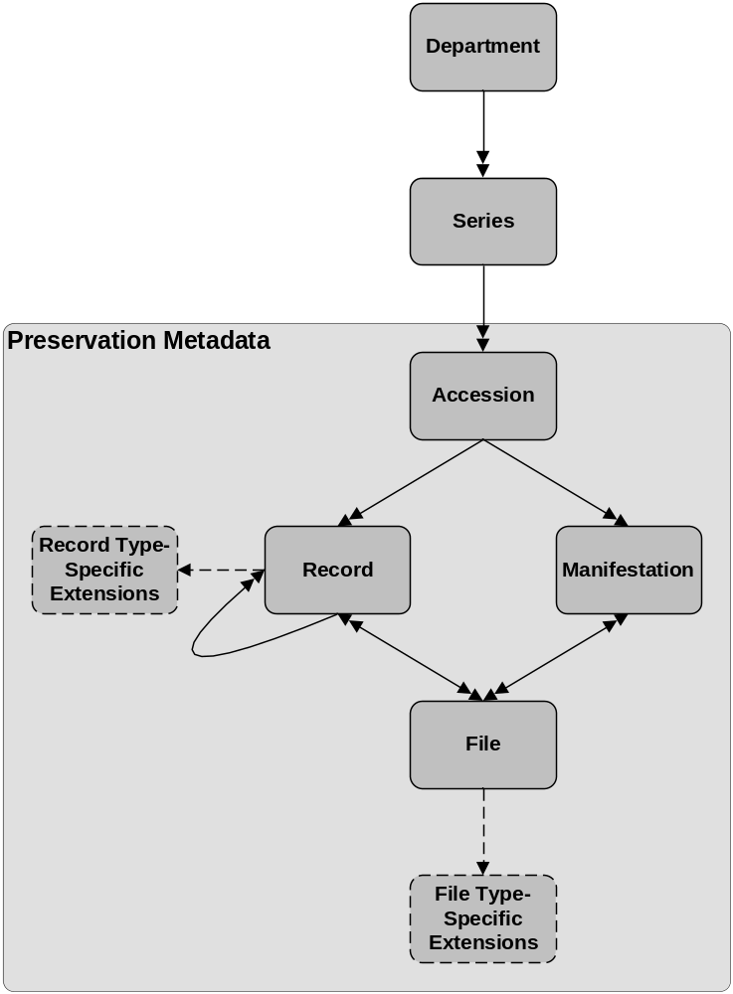

A core business requirement was that the scheme should be compatible with the existing TNA catalogue structure, which is based on ISAD(G). Conceptually, the main TNA catalogue provides resource discovery metadata for all TNA records, including objects stored in the Digital Archive. The preservation metadata scheme was developed as an extension to this catalogue structure, providing additional preservation elements specific to digital records. However, for security and operational reasons, some resource discovery elements are also included in the scheme. These map directly to, and are synchronised with, the equivalent elements in the main catalogue.

The top-level information entity in the preservation metadata information model therefore occupies a position mid-way down the main catalogue hierarchy. The higher level entities of department and series are external to the model, although they are referenced through the TNA (PROCAT) reference number for each record.

The accession entity represents a group of records transferred into the archive as a single collection. As such, an accession may either be a new record series, or an accrual to an existing series. The accession entity is used to record the transfer history of the records into the Digital Archive.

A record represents the conceptual object being stored. Each record may also contain a potentially infinite hierarchy of sub-records. The top-level record always corresponds to a piece within the main catalogue structure. A record may be represented by one or many individual files, which comprise the actual bitstreams stored within the Digital Archive. The scheme separates logical and physical storage structure – each file is stored only once, but may be associated with many logical records.

A record may exist in a number of different technical forms, or manifestations, created to meet requirements for preservation or access. For example, a set of records might originally be accessioned in an obsolete format such as WordStar for DOS. Migration of those records to MS Word format for preservation purposes would create a new manifestation of the same records. A manifestation may comprise one or many files, and files may be shared between multiple manifestations.

The metadata scheme is designed to be extensible, and the information model therefore allows for the definition of additional type-specific entities, with associated element sets. These can be used to provide more detailed descriptions of particular object types, such as images, audio-visual material, or databases. Type-specific elements can extend either record or file entities.

Each entity within this information model is associated with a particular set of metadata elements. These elements are described in the next section.

Metadata Elements

This section describes the individual metadata elements in the scheme. Elements are arranged by entity – for each entity in the information model, an overall metadata map illustrates the arrangements of the various element sub-sets, followed by detailed element descriptions.

  - Accession
The accession element set describes a group of records transferred into the Digital Archive as a single collection.

Metadata Map
Repeatable element sub-sets are marked (R).

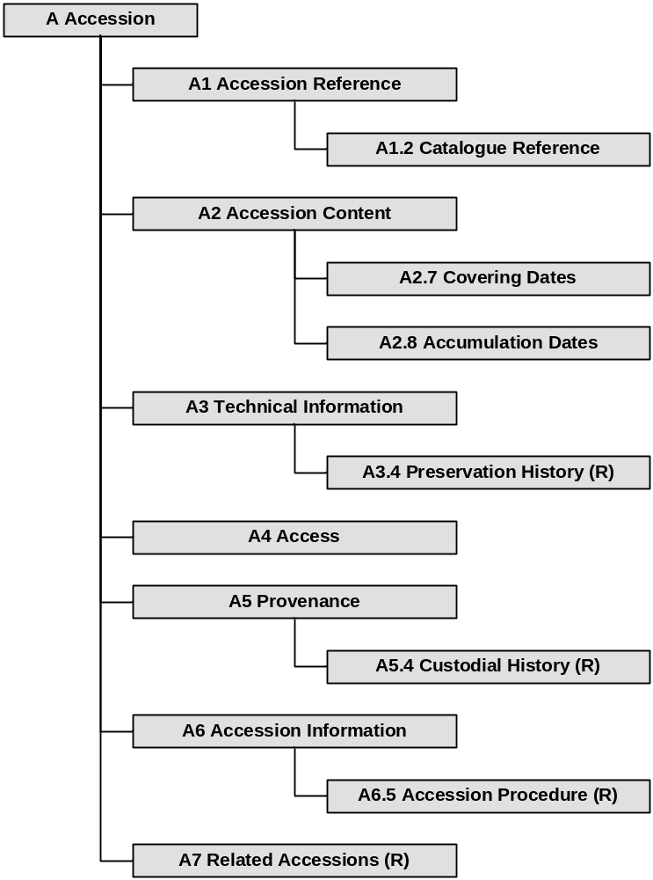

Element Descriptions

A1 Accession Reference
This section describes referencing information for the whole accession.

A1.1 Accession ID
Definition | The unique system identifier assigned to the accession
Mandatory | Y
Controlled | Y – system assigned
Type | Alphanumeric
Example | 20
Comments
Origin

A1.2 Catalogue Reference

A1.2.1 Department Reference
Definition | The full TNA catalogue (PROCAT) Department reference assigned to the records within the accession
Mandatory | Y
Controlled | Y – PROCAT authority file
Type | Alphanumeric
Example | JA
Comments
Origin | TNA Catalogue Metadata

A1.2.2 Series Reference
Definition | The full TNA catalogue (PROCAT) series reference assigned to the records within the accession
Mandatory | Y
Controlled | Y – PROCAT authority file
Type | Alphanumeric
Example | 4
Comments
Origin | TNA Catalogue Metadata

A1.3 Former Reference (External)
Definition | A reference code previously used for an individual record or group of records by an agency outside TNA
Mandatory | N
Controlled | N
Type | Alphanumeric
Example
Comments
Origin | TNA Catalogue Metadata

A1.4 Former Reference (Internal)
Definition | A TNA catalogue (PROCAT) reference previously used for an individual record or group of records.
Mandatory | N
Controlled | N
Type | Alphanumeric
Example
Comments
Origin | TNA Catalogue Metadata

A2 Accession Content
This section describes the content of the accession.

A2.1 Title
Definition | The name given to the accession
Mandatory | Y
Controlled | N
Type | Alphanumeric
Example | PRO 12/25-32 - Public Record Office: Registers, Repairs
Comments
Origin

A2.2 Creator
Definition | Describes the organisation or individual responsible for the content of the accession records up to their declaration as records
Mandatory | Y
Controlled | N
Type | Alphanumeric
Example | Office of Works
Comments
Origin | TNA Catalogue Metadata

A2.3 Significant Properties
Definition | Describes the significant properties of the accession which must be preserved
Mandatory | N
Controlled | N
Type | Alphanumeric
Example
Comments
Origin | OCLC/RLG: Significant Properties

A2.4 Scope and Content
Definition | Synopsis of the form and subject matter within the accession
Mandatory | Y
Controlled | N
Type | Alphanumeric
Example
Comments
Origin | TNA Catalogue Metadata

A2.5 Arrangement
Definition | Describes the logical structure of the accession records, e.g. file structure or data model
Mandatory | N
Controlled | N
Type | Alphanumeric
Example
Comments
Origin | TNA Catalogue Metadata

A2.6 Language
Definition | Describes the native language that the information on the accession records is captured in
Mandatory | Y
Controlled | Y – PROCAT authority file
Type | Alphanumeric
Example | English
Comments | Must comply with ISO 639
Origin | TNA Catalogue Metadata

A2.7 Covering Dates

A2.7.1 Covering Date (From)
Definition | The beginning date for the span which covers the creation of the accession records
Mandatory | Y
Controlled | Y
Type | Date
Example | 2003-12-11
Comments | Conforms to ISO 8061
Origin | TNA Catalogue Metadata

A2.7.2 Covering Date (To)
Definition | The end date for the span which covers the creation of the accession records
Mandatory | Y
Controlled | Y
Type | Date
Example | 2003-12-11
Comments | Conforms to ISO 8061
Origin | TNA Catalogue Metadata

A2.8 Accumulation Dates

A2.8.1 Accumulation Date (From)
Definition | The beginning date for the span which covers the accumulation of the accession records
Mandatory | Y
Controlled | Y
Type | Date
Example | 2003-12-11
Comments | Conforms to ISO 8061
Origin | TNA Catalogue Metadata

A2.8.2 Accumulation Date (To)
Definition | The end date for the span which covers the accumulation of the accession records
Mandatory | Y
Controlled | Y
Type | Date
Example | 2003-12-11
Comments | Conforms to ISO 8061
Origin | TNA Catalogue Metadata

A2.9 Legal Status
Definition | Describes whether or not the records are Public Records
Mandatory | Y
Controlled | Y – PROCAT authority file
Type | Alphanumeric
Example | Public record(s)
Comments
Origin | TNA Catalogue Metadata

A3 Technical Information
This section describes technical information about the accession.

A3.1 Technical Documentation
Definition | Description and location of any documentation on the original technical environment e.g. functional specification, user guides, data dictionaries etc.
Mandatory | N
Controlled | N
Type | Alphanumeric
Example
Comments
Origin

A3.2 Fixity History
Definition | Describes how and when the records have been safeguarded from undocumented alteration prior to accession
Mandatory | N
Controlled | N
Type | Alphanumeric
Example
Comments
Origin

A3.3 Media Description
Definition | Describes the number and file structure of the physical media on which the records were received
Mandatory | N
Controlled | N
Type | Alphanumeric
Example | 2 x CD-Rs, ISO 9660
Comments
Origin

A3.4 Preservation History
This section describes any actions which were undertaken to preserve the accession records prior to their transfer to TNA. This element sub-set is repeatable within accessions.

A3.4.1 Preservation History Event
Definition | Describes the type of event which occurred
Mandatory | Y
Controlled | N
Type | Alphanumeric
Example | Migration to new system
Comments
Origin | OCLC/RLG: Pre-Ingest Designation

A3.4.2 Preservation History Process
Definition | Describes the detailed process involved
Mandatory | Y
Controlled | N
Type | Alphanumeric
Example | Email system migrated from Microsoft Outlook 97 to Microsoft Outlook 2000
Comments
Origin | OCLC/RLG: Pre-Ingest Procedure

A3.4.3 Preservation History Date
Definition | The date on which the procedure took place
Mandatory | Y
Controlled | Y
Type | Date
Example | 2003-11-05
Comments | Conforms to ISO 8061
Origin | OCLC/RLG: Pre-Ingest Date

A3.4.4 Preservation History Agency
Definition | Describes the agency which undertook the procedure
Mandatory | Y
Controlled | N
Type | Alphanumeric
Example | Department of Health
Comments
Origin | OCLC/RLG: Pre-Ingest Responsible Agency
A3.4.5 Preservation History Outcome
Definition | Describes the outcome of the procedure
Mandatory | Y
Controlled | N
Type | Alphanumeric
Example | All files were migrated successfully
Comments
Origin | OCLC/RLG: Pre-Ingest Outcome

A3.4.6 Preservation History Notes
Definition | Describes any other comments on the procedure
Mandatory | N
Controlled | N
Type | Alphanumeric
Example
Comments
Origin | OCLC/RLG: Pre-Ingest Note

A4 Access
This section describes access and security information relating to the accession records.

A4.1 Access Conditions
Definition | Conditions governing access to all the records in an accession
Mandatory | Y
Controlled | Y – PROCAT authority file
Type | Alphanumeric
Example | Subject to 30 year closure
Comments
Origin | TNA Catalogue Metadata

A4.2 Restrictions on Use
Definition | Restrictions on the use or reproduction of the material after access has been granted, e.g. copyright restrictions. This can also include information on physical restrictions
Mandatory | N
Controlled | N
Type | Alphanumeric
Example | Only available by prior arrangement (3 working days)
Comments
Origin | TNA Catalogue Metadata
A5 Provenance
This section describes the provenance of the accession records.

A5.1 Administrative & Biographical History
Definition | Describes administrative, biographical details, or other historical statement about the corporate body or individual responsible for creating and accumulating the records being described.
Mandatory | N
Controlled | N
Type | Alphanumeric
Example
Comments
Origin | TNA Catalogue Metadata

A5.2 Location of Originals
Definition | Describes the location of original records if TNA holds copies
Mandatory | N
Controlled | N
Type | Alphanumeric
Example | National Sound Archive
Comments
Origin | TNA Catalogue Metadata

A5.3 Location of Copies
Definition | Describes the location of copies or renditions of the records
Mandatory | N
Controlled | N
Type | Alphanumeric
Example | Imperial War Museum
Comments
Origin | TNA Catalogue Metadata

A5.4 Custodial History
This section describes changes which have occurred in the custody or ownership of the accession records, up to the point of accession into the Digital Archive. This element sub-set is repeatable within accessions.

A5.4.1 Custody Process
Definition | Describes the custody process which occurred
Mandatory | N
Controlled | N
Type | Alphanumeric
Example | Change of ownership
Comments
Origin | OCLC/RLG: Pre-Ingest Procedure

A5.4.2 Custody Process Date
Definition | The date on which the process occurred
Mandatory | N
Controlled | Y
Type | Date
Example | 2003-11-05
Comments | Conforms to ISO 8061
Origin | OCLC/RLG: Pre-Ingest Date

A5.4.3 Custody Process Source Agency
Definition | Describes the source agency in the custody process
Mandatory | N
Controlled | N
Type | Alphanumeric
Example | The Home Office
Comments
Origin | OCLC/RLG: Pre-Ingest Responsible Agency

A5.4.4 Custody Process Receiving Agency
Definition | Describes the receiving agency in the custody process
Mandatory | N
Controlled | N
Type | Alphanumeric
Example | The National Archives
Comments
Origin | OCLC/RLG: Pre-Ingest Responsible Agency
A5.4.5 Custody Process Notes
Definition | Describes any additional notes on the custody process
Mandatory | N
Controlled | N
Type | Alphanumeric
Example
Comments
Origin | OCLC/RLG: Pre-Ingest Responsible Note

A6 Accession
This section describes the actual accession of records into the Digital Archive.

A6.1 Accession Date
Definition | The date on which the records were accessioned into the Digital Archive
Mandatory | Y
Controlled | Y
Type | Date
Example | 2003-11-11
Comments | Conforms to ISO 8061
Origin | TNA Catalogue Metadata

A6.2 Place of Deposit
Definition | Describes the authority controlled name of the repository holding the record
Mandatory | Y
Controlled | Y
Type | Alphanumeric
Example | The National Archives, Kew
Comments
Origin | TNA Catalogue Metadata

A6.3 Immediate Source of Acquisition
Definition | The name of the corporate body or person from which the records were acquired
Mandatory | Y
Controlled | Y – PROCAT authority file
Type | Alphanumeric
Example | Foreign and Commonwealth Office
Comments
Origin | TNA Catalogue Metadata
A6.4 Disposition Information
Definition | Information on any appraisal, scheduling and destruction actions, e.g. is it a sample, was it transferred under FOI? This should include the section of the acquisition policy under which the record was accessioned
Mandatory | Y
Controlled | N
Type | Alphanumeric
Example | PRO acquisition policy collection theme 2.2.1.1
Comments
Origin | TNA Catalogue Metadata

A6.5 Accession Procedure
This section describes the events undertaken as part of the accession procedure. This element sub-set is repeatable within accessions.

A6.5.1 Accession Procedure Event
Definition | Describes the event which occurred
Mandatory | Y
Controlled | N
Type | Alphanumeric
Example | File transfer to DP server
Comments
Origin | OCLC/RLG: Ingest Designation

A6.5.2 Accession Procedure Process
Definition | Describes the detailed process involved
Mandatory | Y
Controlled | N
Type | Alphanumeric
Example | The files were copied from the TNA network onto the digital archive workstation, via removable media, for loading
Comments
Origin | OCLC/RLG: Ingest Procedure

A6.5.3 Accession Procedure Date
Definition | The date on which the procedure took place
Mandatory | Y
Controlled | Y
Type | Date
Example | 2003-11-05
Comments | Conforms to ISO 8061
Origin | OCLC/RLG: Ingest Date

A6.5.4 Accession Procedure Agency
Definition | Describes the agency which undertook the procedure
Mandatory | Y
Controlled | N
Type | Alphanumeric
Example | TNA Digital Preservation Department
Comments
Origin | OCLC/RLG: Ingest Responsible Agency

A6.5.5 Accession Procedure Outcome
Definition | Describes the outcome of the procedure
Mandatory | Y
Controlled | N
Type | Alphanumeric
Example | All files were transferred successfully
Comments
Origin | OCLC/RLG: Ingest Outcome

A6.5.6 Accession Procedure Notes
Definition | Describes any other comments on the procedure
Mandatory | N
Controlled | N
Type | Alphanumeric
Example
Comments
Origin | OCLC/RLG: Ingest Note

A7 Related Accessions
This section describes relationships between accessions. This element sub-set is repeatable within accessions.

A7.1 Accession Relationship Type
Definition | Describes the type of relationship between the current and cited accession
Mandatory | N
Controlled | N
Type | Alphanumeric
Example | Accrues from
Comments
Origin

A7.2 Related Accession ID
Definition | The unique system identifier of the related accession
Mandatory | N
Controlled | Y – system assigned
Type | Alphanumeric
Example | 200
Comments
Origin

  - Record
The record element set describes each record transferred into the Digital Archive within an accession.

Metadata Map
Repeatable element sub-sets are marked (R).

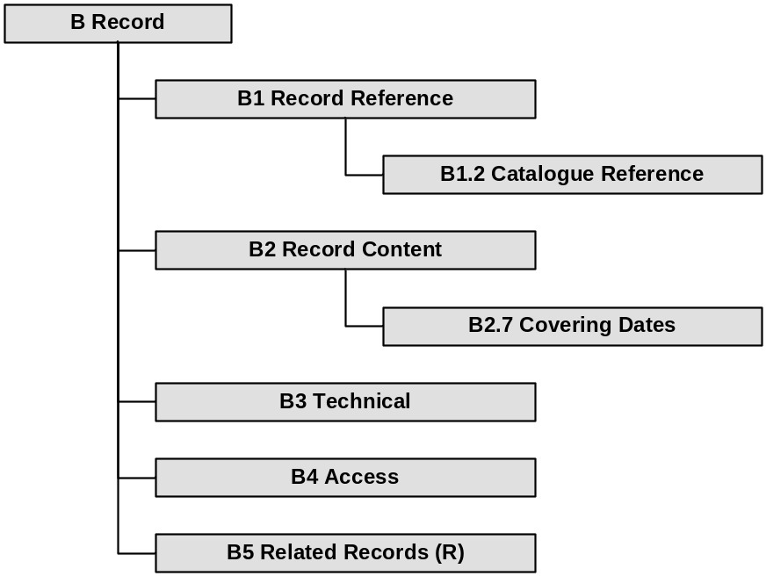

Element Descriptions

B1 Record Reference
This section describes referencing information for the record.

B1.1 Record ID
Definition | The unique system identifier assigned to the record
Mandatory | Y
Controlled | Y – system assigned
Type | Alphanumeric
Example | 20-1
Comments
Origin

B1.2 Catalogue Reference

B1.2.1 Department Reference
Definition | The full TNA catalogue (PROCAT) Department reference assigned to the records within the accession
Mandatory | Y
Controlled | Y – PROCAT authority file
Type | Alphanumeric
Example | JA
Comments
Origin | TNA Catalogue Metadata

B1.2.2 Series Reference
Definition | The full TNA catalogue (PROCAT) series reference assigned to the records within the accession
Mandatory | Y
Controlled | Y – PROCAT authority file
Type | Alphanumeric
Example | 4
Comments
Origin | TNA Catalogue Metadata

B1.2.3 Piece Reference
Definition | The full TNA catalogue (PROCAT) piece reference assigned to the record
Mandatory | Y
Controlled | Y – PROCAT authority file
Type | Alphanumeric
Example | 1
Comments
Origin | TNA Catalogue Metadata

B1.2.4 Item Reference
Definition | The full TNA catalogue (PROCAT) item reference assigned to the record
Mandatory | Y
Controlled | Y – PROCAT authority file
Type | Alphanumeric
Example | 1
Comments
Origin | TNA Catalogue Metadata

B1.3 Former Reference (External)
Definition | A reference code previously used for an individual record or group of records by an agency outside TNA
Mandatory | N
Controlled | N
Type | Alphanumeric
Example
Comments
Origin | TNA Catalogue Metadata

B1.4 Former Reference (Internal)
Definition | A TNA catalogue (PROCAT) reference previously used for an individual record or group of records.
Mandatory | N
Controlled | N
Type | Alphanumeric
Example
Comments
Origin | TNA Catalogue Metadata

B2 Record Content
This section describes the content of the record.

B2.1 Title
Definition | The name given to the record
Mandatory | N
Controlled | N
Type | Alphanumeric
Example | WORK 90/1
Comments
Origin | TNA Catalogue Metadata

B2.2 Creator
Definition | Describes the organisation or individual responsible for the content of the record up to its declaration as a record
Mandatory | N
Controlled | N
Type | Alphanumeric
Example | Bloody Sunday Inquiry
Comments
Origin | TNA Catalogue Metadata

B2.3 Significant Properties
Definition | Describes the significant properties of the record which must be preserved
Mandatory | N
Controlled | N
Type | Alphanumeric
Example
Comments
Origin | OCLC/RLG: Significant Properties

B2.4 Scope and Content
Definition | Synopsis of the form and subject matter within the records
Mandatory | Y
Controlled | N
Type | Alphanumeric
Example
Comments
Origin | TNA Catalogue Metadata
B2.5 Arrangement
Definition | Describes the logical structure of the record, e.g. file structure or data model
Mandatory | N
Controlled | N
Type | Alphanumeric
Example
Comments
Origin | TNA Catalogue Metadata

B2.6 Language
Definition | Describes the native language that the information on the records is captured in
Mandatory | N
Controlled | Y – PROCAT authority file
Type | Alphanumeric
Example | English
Comments | Must comply with ISO 639
Origin | TNA Catalogue Metadata

B2.7 Covering Dates

B2.7.1 Covering Date (From)
Definition | The beginning date for the span which covers the creation of the record
Mandatory | Y
Controlled | Y
Type | Date
Example | 2003-12-11
Comments | Conforms to ISO 8061
Origin | TNA Catalogue Metadata

B2.7.2 Covering Date (To)
Definition | The end date for the span which covers the creation of the record
Mandatory | Y
Controlled | Y
Type | Date
Example | 2003-12-11
Comments | Conforms to ISO 8061
Origin | TNA Catalogue Metadata
B2.8 Record Declaration Date
Definition | The date on which the record was formally declared as such
Mandatory | N
Controlled | Y
Type | Date
Example | 2003-12-11
Comments | Conforms to ISO 8061
Origin

B2.9 Record Type
Definition | Describes the generic type of the record
Mandatory | Y
Controlled | Y
Type | Alphanumeric
Example | Website
Comments | This element controls the applicability of record level type-specific metadata extensions
Origin | NLA: Structural Type

B3 Technical Information
This section describes technical information about the record.

B3.1 Password
Definition | Describes any password required to access the record if the system does not permit password removal
Mandatory | N
Controlled | N
Type | Alphanumeric
Example | Guest1
Comments
Origin

B3.2 Encryption
Definition | Describes any encryption method used previously (this would be removed prior to loading)
Mandatory | N
Controlled | N
Type | Alphanumeric
Example | PGP Desktop 8.0.3
Comments
Origin | VERS: Encryption Details

B4 Access
This section describes the access and security conditions relating to use of the record.

B4.1 Security Category
Definition | The protective marking on the record
Mandatory | N
Controlled | Y
Type | Alphanumeric
Example | Restricted
Comments
Origin | VERS: Security Classification

B4.2 Closure Type
Definition | Conditions governing access to the record
Mandatory | Y
Controlled | Y – PROCAT authority file
Type | Alphanumeric
Example | Closed for
Comments
Origin | TNA Catalogue Metadata

B4.3 Closure Code
Definition | The code associated with the Closure Type element
Mandatory | N
Controlled | N
Type | Alphanumeric
Example | 30
Comments
Origin | TNA Catalogue Metadata

B4.4 Closure Status
Definition | Current closure status of the record and description
Mandatory | Y
Controlled | Y – PROCAT authority file
Type | Alphanumeric
Example | Open record, open description
Comments
Origin | TNA Catalogue Metadata

B4.5 Restrictions on Use
Definition | Restrictions on the use or reproduction of the material after access has been granted, e.g. copyright restrictions. This can also include information on physical restrictions
Mandatory | N
Controlled | N
Type | Alphanumeric
Example | Only available by prior arrangement (3 working days)
Comments
Origin | TNA Catalogue Metadata

B4.6 Record Opening Date
Definition | The date when the record was or will be opened
Mandatory | Y
Controlled | Y
Type | Date
Example | 2003-11-05
Comments | Conforms to ISO 8061
Origin | TNA Catalogue Metadata

B5 Related Records
This section describes relationships between records. This element sub-set is repeatable within records.

B5.1 Record Relationship Type
Definition | Describes the type of relationship between the current and cited record
Mandatory | N
Controlled | N
Type | Alphanumeric
Example | Describes
Comments
Origin

B5.2 Related Record ID
Definition | The unique system identifier of the related record
Mandatory | N
Controlled | Y – system assigned
Type | Alphanumeric
Example | 200-5
Comments
Origin

  - Manifestation
The Manifestation element set describes the nature, provenance, and detailed technical dependencies of each manifestation.

Metadata Map
Repeatable element sub-sets are marked (R).

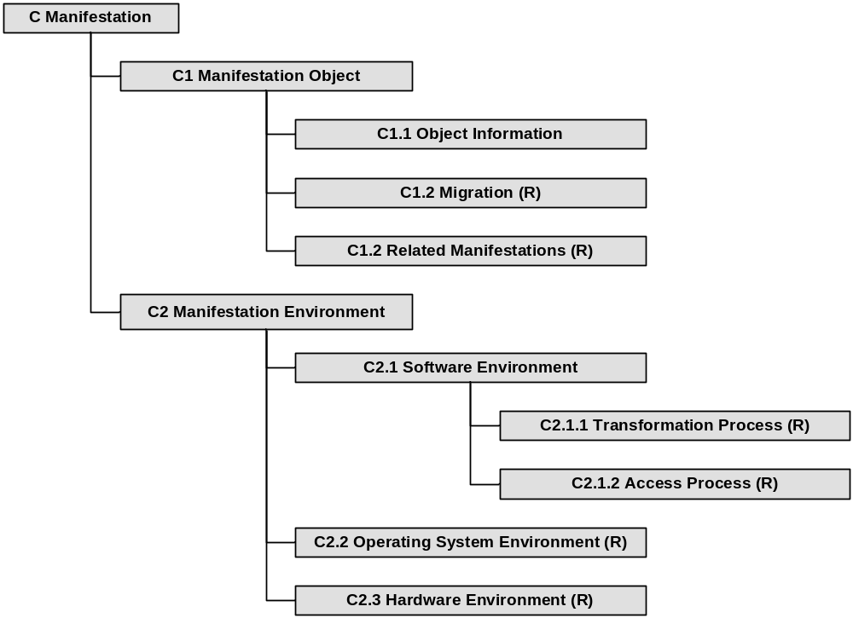

Element Descriptions

C1 Object
This section describes the nature of the manifestation and its associated migration pathways.

C1.1 Object Information
This section describes information about the manifestation object itself.

C1.1.1 Manifestation ID
Definition | The unique system identifier assigned to each manifestation
Mandatory | Y
Controlled | Y – system assigned
Type | Alphanumeric
Example | 20-M1
Comments
Origin | CfA: Manifestation Metadata

C1.1.2 Manifestation Type
Definition | Description of the type of manifestation
Mandatory | Y
Controlled | N
Type | Alphanumeric
Example | HTML manifestation
Comments
Origin | CfA: Manifestation Metadata

C1.1.3 Manifestation Status
Definition | The current status of the manifestation
Mandatory | Y
Controlled | Y
Type | Alphanumeric
Example | Current
Comments
Origin | CfA: Manifestation Metadata

C1.1.4 Manifestation Structure
Definition | Description of any complex components of the manifested object and their interrelationships
Mandatory | N
Controlled | N
Type | Alphanumeric
Example | This manifestation comprises 7 unlinked Excel 2000 worksheet files and 1 Access 2000 database file
Comments
Origin | CfA: Manifestation Metadata; CEDARS: Underlying Abstract Form

C1.1.5 Manifestation Documentation
Definition | Reference to any associated documentation for the manifestation
Mandatory | N
Controlled | N
Type | Alphanumeric
Example | My System User Guide
Comments
Origin | CfA: Manifestation Metadata

C1.1.6 Installation Requirements
Definition | Any procedures required to install and run the manifestation for access
Mandatory | N
Controlled | N
Type | Alphanumeric
Example | Open “index.htm” in root folder to view
Comments
Origin | NLNZ :Installation Requirements; NLA: Installation Requirements

C1.1.7 Manifestation Notes
Definition | Any additional notes on the manifestation
Mandatory | N
Controlled | N
Type | Alphanumeric
Example
Comments
Origin | CfA: Manifestation Metadata

C1.2 Migration
This section describes the migration pathway(s) used to create the manifestation. This element sub-set is repeatable within manifestations.

C1.2.1 Migration Date
Definition | The date on which the migration event was conducted
Mandatory | Y
Controlled | Y
Type | Date
Example | 2003-11-05
Comments | Conforms to ISO 8061
Origin | CfA: Migration Pathway Metadata

C1.2.2 Migration Pathway ID
Definition | The unique identifier of the migration pathway used
Mandatory | Y
Controlled | Y – system assigned
Type | Alphanumeric
Example | 7
Comments
Origin | CfA: Migration Pathway Metadata

C1.2.3 Migration Agency
Definition | Describes the individual or agency which undertook the migration process
Mandatory | Y
Controlled | N
Type | Alphanumeric
Example | TNA Digital Preservation Department
Comments
Origin | CfA: Migration Pathway Metadata

C1.2.4 Migration Certificate
Definition | Details of any layout, content or functionality lost in migration, discrepancies and corrections
Mandatory | N
Controlled | N
Type | Alphanumeric
Example
Comments
Origin | CfA: Migration Pathway Metadata
C1.3 Related Manifestations
This section describes relationships between manifestations of a record. This element sub-set is repeatable within manifestations.

C1.3.1 Manifestation Relationship Type
Definition | Describes the type of relationship between the current and cited manifestation
Mandatory | N
Controlled | Y
Type | Alphanumeric
Example | Migrated from
Comments
Origin | CfA: Manifestation Metadata

C1.3.2 Related Manifestation ID
Definition | The unique system identifier of the related manifestation
Mandatory | N
Controlled | Y – system assigned
Type | Alphanumeric
Example | 15-M0
Comments
Origin | CfA: Manifestation Metadata

C2 Environment
This section describes the technical environment required to access the manifestation.

C2.1 Software Environment
This section describes the software environment required to access the manifestation.

C2.1.1 Transformation Process
This section describes the process required to transform the stored bit stream into an accessible form. This element sub-set is repeatable within manifestations.

C2.1.1.1 Transformation Engine
Definition | The name and version of the software required to transform the object
Mandatory | N
Controlled | N
Type | Alphanumeric
Example | WinZip Version 8.1
Comments
Origin | CEDARS: Transformer Object
C2.1.1.2 Transformation Parameters
Definition | Description of any runtime parameters required for the transformation engine
Mandatory | N
Controlled | N
Type | Alphanumeric
Example | Unzip files to C:\Program Files\My Software\
Comments
Origin | CEDARS: Transformer Object

C2.1.1.3 Transformation Engine Location
Definition | Description of the location of the required transformation engine environment
Mandatory | N
Controlled | N
Type | Alphanumeric
Example | TNA Software Library, ISO Image 546
Comments
Origin | OCLC/RLG: Location

C2.1.1.4 Transformation Engine Documentation
Definition | Reference to any associated documentation for the required transformation engine
Mandatory | N
Controlled | N
Type | Alphanumeric
Example | WinZip Version 8.1 User Guide
Comments
Origin | OCLC/RLG: Documentation

C2.1.2 Access Process
This section describes the process required to access the transformed bit stream. This element sub-set is repeatable within manifestations.

C2.1.2.1 Access Engine
Definition | The name and version of the software required to display the object and access its intellectual content
Mandatory | N
Controlled | N
Type | Alphanumeric
Example | Adobe Acrobat Reader Version 5.0.5
Comments
Origin | OCLC/RLG: Display/Access Application

C2.1.2.2 Access Engine Location
Definition | Description of the location of the required access engine environment
Mandatory | N
Controlled | N
Type | Alphanumeric
Example | TNA Software Library, ISO Image 312
Comments
Origin | OCLC/RLG: Location

C2.1.2.3 Access Engine Documentation
Definition | Reference to any associated documentation for the required access engine
Mandatory | N
Controlled | N
Type | Alphanumeric
Example | Adobe Acrobat Reader 5 User Guide
Comments
Origin | OCLC/RLG: Documentation

C2.2 Operating System Environment
This section describes the operating system environment required to access the manifestation. This element sub-set is repeatable within manifestations.

C2.2.1 OS Name
Definition | The official name of the required operating system
Mandatory | N
Controlled | N
Type | Alphanumeric
Example | Microsoft Windows XP
Comments
Origin | NEDLIB: OS Name

C2.2.2 OS Version
Definition | The required operating system edition, version, and patch/service pack level
Mandatory | N
Controlled | N
Type | Alphanumeric
Example | Professional Edition, Version 2002, Service Pack 1
Comments
Origin | NEDLIB: OS Version

C2.2.3 OS Location
Definition | Description of the location of the required operating system environment
Mandatory | N
Controlled | N
Type | Alphanumeric
Example | TNA Digital Preservation Computer Laboratory, Workstation 5
Comments
Origin | OCLC/RLG: Location

C2.2.4 OS Documentation
Definition | Reference to any associated documentation for the required operating system environment
Mandatory | N
Controlled | N
Type | Alphanumeric
Example
Comments
Origin | OCLC/RLG: Documentation

C2.3 Hardware Environment
This section describes the hardware environment required to access the manifestation. This element sub-set is repeatable within manifestations.

C2.3.1 CPU Requirements
Definition | The minimum CPU type and speed requirement
Mandatory | N
Controlled | N
Type | Alphanumeric
Example | AMD Athlon XP 1700+ 1.4GHz
Comments
Origin | NEDLIB: Microprocessor Requirements

C2.3.2 RAM Requirements
Definition | The minimum RAM requirement
Mandatory | N
Controlled | N
Type | Alphanumeric
Example | 256 MB
Comments
Origin | OCLC/RLG: Memory Requirements

C2.3.3 Storage Requirements
Definition | The minimum free hard disk space requirement
Mandatory | N
Controlled | N
Type | Alphanumeric
Example | 10 GB
Comments
Origin | OCLC/RLG: Storage Information

C2.3.4 Peripheral Requirements
Definition | Additional peripheral requirements, including sound and graphics cards, dongles etc.
Mandatory | N
Controlled | N
Type | Alphanumeric
Example | SoundBlaster-compatible sound card
Comments
Origin | NEDLIB: Peripheral Requirements

C2.3.5 Hardware Location
Definition | Description of the location of the required hardware environment
Mandatory | N
Controlled | N
Type | Alphanumeric
Example | TNA Digital Preservation Computer Laboratory
Comments | OCLC/RLG: Location
Origin

C2.3.6 Hardware Documentation
Definition | Reference to any associated documentation for the required hardware environment
Mandatory | N
Controlled | N
Type | Alphanumeric
Example
Comments
Origin | OCLC/RLG: Documentation

  - File
The file element set describes an individual file which forms part of a record.

Metadata Map
Repeatable element sub-sets are marked (R).

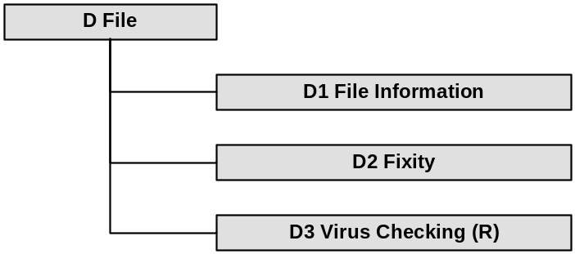

Element Descriptions

D1 File Information
This section describes the basic characteristics of each file. All elements are system-populated as part of the accession process.

D1.1 File ID
Definition | Describes the unique system identifier assigned to each file
Mandatory | Y
Controlled | Y – system assigned
Type | Alphanumeric
Example | 20-1
Comments
Origin

D1.2 Original File Name
Definition | Describes the original system file name
Mandatory | Y
Controlled | N
Type | Alphanumeric
Example | My Document.doc
Comments
Origin

D1.3 System File Name
Definition | Describes any system file name assigned to the file by the Digital Archive
Mandatory | N
Controlled | N
Type | Alphanumeric
Example | 20-1-2 My Document.pdf
Comments
Origin

D1.4 Original File Path
Definition | Describes the original system file path, relative to the root folder for the accessioned files
Mandatory | Y
Controlled | N
Type | Alphanumeric
Example | IEGMP\Reports\2000\
Comments
Origin

D1.5 File Format ID
Definition | Describes the PRONOM unique identifier for the file format
Mandatory | Y
Controlled | Y – PRONOM authority file
Type | Alphanumeric
Example | Tiff/6.0
Comments
Origin | PRONOM

D1.6 File Format Name
Definition | Describes the name of the file format
Mandatory | Y
Controlled | Y – PRONOM authority file
Type | Alphanumeric
Example | Tagged Image File Format, Revision 6.0
Comments
Origin | PRONOM

D1.7 File Size
Definition | The physical size of the file in bytes
Mandatory | Y
Controlled | N
Type | Numeric
Example | 825605
Comments
Origin

D1.8 File Creation Date
Definition | The system date on which the file was created
Mandatory | Yes
Controlled | Y
Type | Date
Example | 2003-12-05T09:17
Comments | Conforms to ISO 8061
Origin

D2 Fixity
This section describes the fixity method used by the Digital Archive to ensure the integrity of the file. This process is performed automatically, and all elements are system-populated as part of the accession process.

D2.1 Fixity Type
Definition | Describes the technique used to generate the file fixity value
Mandatory | Y
Controlled | Y
Type | Alphanumeric
Example | MD5 digest algorithm
Comments
Origin | CfA: Fixity Metadata

D2.2 Fixity Method
Definition | Describes the method used to generate the fixity value
Mandatory | Y
Controlled | Y
Type | Alphanumeric
Example | MD5 Summer version 1.1.0.22
Comments
Origin | CfA: Fixity Metadata

D2.3 Fixity Method Documentation
Definition | Describes a reference to documentation for the fixity method
Mandatory | Y
Controlled | Y
Type | Alphanumeric
Example | RFC 1321 – The MD5 message digest algorithm (R Rivest, 1992)
Comments
Origin | CfA: Fixity Metadata

D2.4 Fixity Date
Definition | The date on which the fixity value was generated
Mandatory | Y
Controlled | Y
Type | Date
Example | 2003-11-05T17:23
Comments | Conforms to ISO 8061
Origin | CfA: Fixity Metadata

D2.5 Fixity Value
Definition | Describes the fixity value generated
Mandatory | Y
Controlled | N
Type | Alphanumeric
Example | 98478b17d2c116b9822581f967fd6fee
Comments
Origin | CfA: Fixity Metadata

D3 Virus Checking
This section describes the method used to scan the file for viruses upon accession. This process is performed automatically, and all elements are system-populated as part of the accession process. This element sub-set is repeatable within files.

D3.1 Virus Checker ID
Definition | Describes the unique system identifier of the virus checker used
Mandatory | Y
Controlled | Y – system assigned
Type | Numeric
Example | 1
Comments
Origin

D3.2 Virus Checker Name
Definition | Describes the name of the software used to perform the scan
Mandatory | Y
Controlled | Y
Type | Alphanumeric
Example | Sophos Antivirus v5.0
Comments
Origin

D3.3 Virus Checker Engine
Definition | Describes the virus scan engine used to perform the scan
Mandatory | Y
Controlled | Y
Type | Alphanumeric
Example | 2.14
Comments
Origin

D3.4 Virus Definition File
Definition | Describes the full version of the virus definition file used to perform the scan
Mandatory | Y
Controlled | Y
Type | Alphanumeric
Example | 3.71
Comments
Origin

D3.5 Scan Date
Definition | The date and time on which the file was virus checked
Mandatory | Y
Controlled | Y
Type | Date
Example | 2003-12-11T12:07
Comments | Conforms to ISO 8061
Origin

  - Type-specific extensions

No type-specific element sets have yet been implemented. However, some draft element sets are given for illustrative purposes. Type-specific extensions may apply to either record or file entities. For example, a website or email which is captured as a record may require some specific metadata elements which will apply irrespective of its manifestation in any specific technical environment. Equally, individual files may require additional descriptive metadata at a technical level.

E1 Record Type-Specific Extensions
Extended metadata sub-sets may be required for type-specific information which applies to the informational content and character of a record. The use of these would be triggered depending on values in the Record Type element (B2.9). The following are provided as examples.

E1.1 Website

Original URL
Original Host

E1.2 Email

Sender Email Address
Recipient Email Address(es)
CC Email Address(es)
BC Email Address(es)
Transmission Date
Subject
Content
Attachments

Note: technical elements such as MIME Version, Content Type and Character Set would form part of a file type-specific extension.

E2 File Type-Specific Extensions
Extended metadata sub-sets may be required for type-specific information which applies to the technical characteristics of a file. The use of these would be triggered depending on values in the File Format ID element (D1.5). The following are provided as examples.

E2.1 Raster Images

Resolution
Dimensions
Bit Depth
Colour Space
Colour Management
Colour Look-Up Table
Compression

E2.2 Audio/Visual

Audio Sampling Frequency
Duration
Audio Bit Rate
Video Bit Depth
Audio Compression
Video Compression
Encapsulation
Dimensions
Frame Rate
Channels

Bibliography

CfA Preservation Metadata
Brown, A, 2002, Centre for Archaeology Digital Archiving Strategy (Version 2.0), English Heritage

http://www.english-heritage.org.uk/Filestore/archaeology/pdf/das_2.pdf [Viewed 12 December 2003]

CEDARS
Russell, K et al, 2000, Metadata for Digital Preservation: The Cedars Project Outline Specification, Cedars/UKOLN

http://www.leeds.ac.uk/cedars/colman/metadata/metadataspec.html [Viewed 12 December 2003]

National Library of Australia
Webb, C, 1999, Preservation Metadata for Digital Collections: Exposure Draft, National Library of Australia

http://www.nla.gov.au/preserve/pmeta.html [Viewed 12 December 2003]

National Library of New Zealand
National Library of New Zealand, 2003, Metadata Standards Framework: Preservation Metadata (Revised)

http://www.natlib.govt.nz/files/4initiatives_metaschema_revised.pdf [Viewed 12 December 2003]

NEDLIB
Lupovici, C and Masanès, J, 2000, Metadata for Long-Term Preservation, NEDLIB Consortium

http://www.kb.nl/coop/nedlib/results/D4.2/D4.2.htm [Viewed 12 December 2003]

OCLC/RLG
OCLC/RLG Working Group on Preservation Metadata, 2002, Preservation Metadata and the OAIS Information Model: A Metadata Framework to Support the Preservation of Digital Objects, Online Computer Library Center

http://www.oclc.org/research/projects/pmwg/pm_framework.pdf [Viewed 12 December 2003]

VERS
Public Record Office Victoria, 2003, PROS 99/007 (Version 2) Specification 2: VERS Metadata Scheme

http://www.prov.vic.gov.au/vers/standards/pros9907vers2/spec_02/default.htm [Viewed 12 December 2003]

